è Exam question links
Shared Responsibility Model:
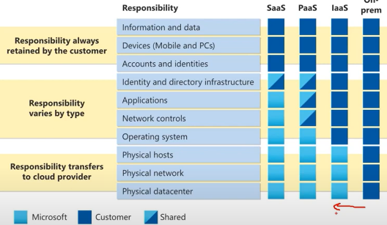

EC2 Elastic Computer Cloud : virtual host with access to Os and apps…
USER HAS TO MANAGE IT still: secure, patch os, apps , in/decrease n#...
- Uses Multitenancy: virtual servers on top of fskl machines thanks to a Hypervisor
- Vertically scalable: in/decrease capacity
- Configurable: hardware, OS,Security settings, apps, DBs, pckgs…:
- Templates/EC2 families:
  - General Purpose
  - Compute optimized(high-performance processors (Batch processing, Gaming srvrs))
  - Memory optimized(RAM, large amounts of data to be preloaded before running an application )
  - Accelerated Computing: HW acc
  - Storage Optimized: High input/output operations per second (IOPS)
- Billing:
  - On-demand
  - Saving-plan: discounts for specific amount ($/hour) of compute usage for 1 or 3 years
  - Reserved: discount for rsrving instance in a region for 1 or 3yrs [sndrds vs cnvrtbl]
  - Dedicated Hosts: fully dedctd physical servers
  - Spot instance: metbe3ouch, retakenat any time
- Scalability & Elasticity (Amazon AutoScaling):
  - Add/rmv EC2s
  - Dynamic scaling responds to changing demand.
  - Predictive scaling automatically schedules the right number of Amazon EC2 instances based on predicted demand.
  - Decoupling the system: make the app many separate, scallable, parts that do their jobs and communicate
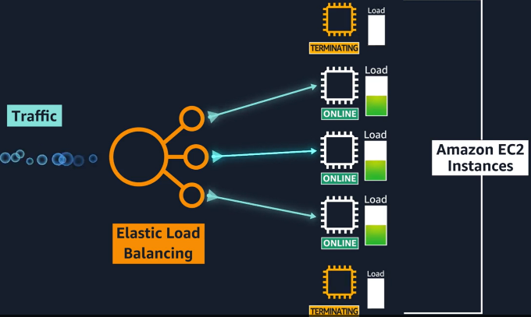
ELB Elastic Load Balancer:
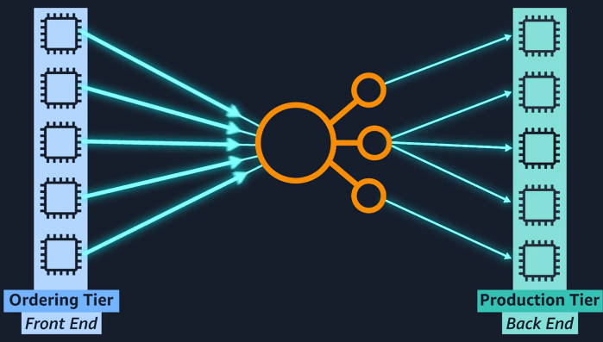
- Regional Construct , not in EC2 => Highly available
- Routes extrnl & intrnl traffic to (least trfc loaded) EC2 as AutoScales adds or rmvs them.
- Grows with traffic and n° of EC2s (Cluster)

Messaging and queuing:
- Tightly coupled: an issue in a compnnt causes errors in others.
- Loosely coupled Architectures: uses a Buffer/Queue between cmpnnts to avoid that pblm.
- SQS Simple queue service: msgs payloads in queues btwn services
- SNS Simple notification service (Pub/Sub model):
Serverless: Everything is taken care of aka. No need for srvr management:
- AWS LAMBDA: a Lambda Function waits for trigger to execute code <15min [SERVERLESS]
  - Serverless ~PaaS sleeps until triggered
- Docker Container: uses OS-lvl Virtualzation,◈Container: Pckg for everything apps need. Clusters if they re so many, need to be managed with Container Orchestration Tools working on top of EC2s:
  - ECS Elastic Container Service:
  - EKS Elastic Kubernetes Service:
Or serverless on
- AWS Fargate: Engine for containers, works with ECS & EKS
Selecting Regions :
- Consider proximity to Customers
- must deploy apps in +1 EC2s in mltpl regions: grp of availability zones(~10km apart Datacenters) around the wrld
- Cloud Front uses Edge Location: site where AWS stores/caches copies of data in locations without DCs
API Application Programming Interface: are used to launch, create, delete … through:
DIY…:  - AWS management console (Web Based)  - AWS CLI (Commands)  - AWS SDKs Software Dev Kits (Programs) | Give it a Template and it qckly deploys…:  - Elastic Beanstalk  - Cloud Formation

AWS Networks

Public subnets: accessible to internet (servers) through an IGW which routes traffic to the outside by default <-- so the internal VPC router should have a route 0.0.0.0/0 --> IGW
Private subnets: inaccessbile, can access internet through NAT
Amazon VPC Virtual Private Cloud: Private ntwrk in Cloud
- Requires Internet Gateway to be accessible to the public on the internet
- Requires a Virtual Private Gateway to be accessible to trusted ntwrks à creates VPN connection
- Amazon Direct Connect: direct Fiber cnction to aws
- Contain Subnets (Private ip ranges) :
  - seperates rsrcs u want pblc from rsrcs u want prvt
  - cntrl traffic perms:
    - checks in/out pckts agnst a network ACL access control list: is stateless, by dflt lets all in/out traffic (empty list)
    - Security Group : vrtual fw , is statful , By dflt it allows all out and stops all in pckts
Route 53: Routing + DNS fcts
VPC Endpoint: Allows resources inside a private subnet to securely communicate with other services outside the VPC without requiring an Internet Gateway or NAT Gateway. It achieves this by assigning a private IP address directly inside your subnet using an AWS Elastic Network Interface (ENI).
AWS PrivateLink: Is the underlying technology used when I want to expose my custom service, allowing other AWS accounts and VPCs to access it privately without complex network peering
==>
- One account owner builds a service, exposes it by creating a VPC Endpoint Service powered by PrivateLink, has a unique Service Name.
- Log into your AWS account and create an Interface VPC Endpoint using that shared Service Name.
- AWS places an Elastic Network Interface (ENI) inside my VPC so its resources can now call that local private IP address to instantly, securely, and privately access the other account's service over the AWS backbone network completely bypassing the public internet.

AWS Storage

Istance Store: fskl built-in SSD/HDD in the server your EC2 is running on, Goes awy with EC2
EFS Elastic File System: file system in Linux, Regional, shared, scalable, multiple AZs
EBS Elastic Block Sorage: vrtl persistent hard drives, fixed size, attachable to EC2in same AZ, max 16TB.
S3 Simple Storage Service: file~objct as a whole==for each update reupload(500GB) in hdd~bucket, can Version objcts, attrbt permissions, unlimited gb:

- S3 Standard: for Frequently accessed data, high durability (11 nines = 99.999999999%),
Moving objct could be automated
stored at +3 Availability Zones, web-enabledè can host wbstes if has html blocks
- Amazon S3 Intelligent-Tierin : Monitor, change between tiers
- S3 Standard-Infrequent Access (IA): for Backups, fast retrieval
- S3 Glacier Flexible Retrieval : Long-term, slow retrieval
Snapshot Bckup
Amazon RDS Relational Database Service: db without the mngmnt hassel, secure
Amazon Aurora: for high-availability DBs ,by storing data across 6 AZs
Amazon Dynamo: new typee Non-Relational/Non-SQL DB, redundancy, scalable, performant,
Amazon Redshift : uses Data Warehouse: Big data
Amazon DMS Data Migration Service:
Amazon QLDB Quantum Ledger Database: Data History in app
AWS Snowmobile: Which service is used to transfer up to 100 PB of data to AWS?

